Lab-7 :

1. Plot graphs for Accuracy and Loss Function for VGG16 and VGG19 (4 graphs in total):

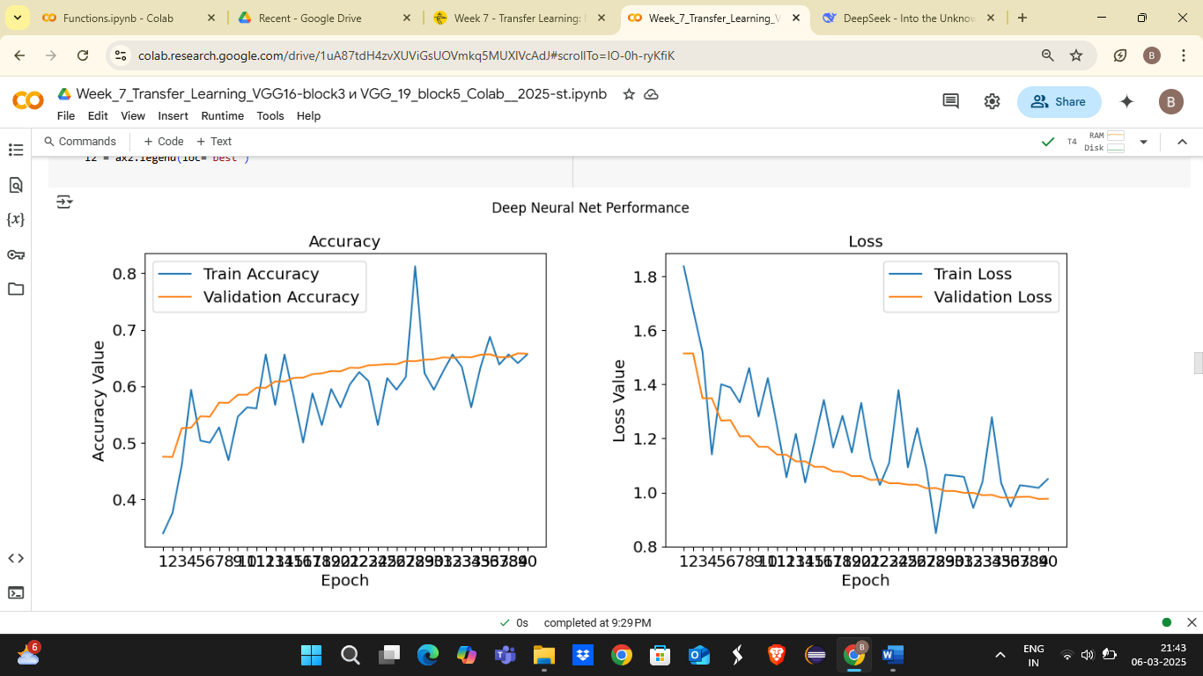

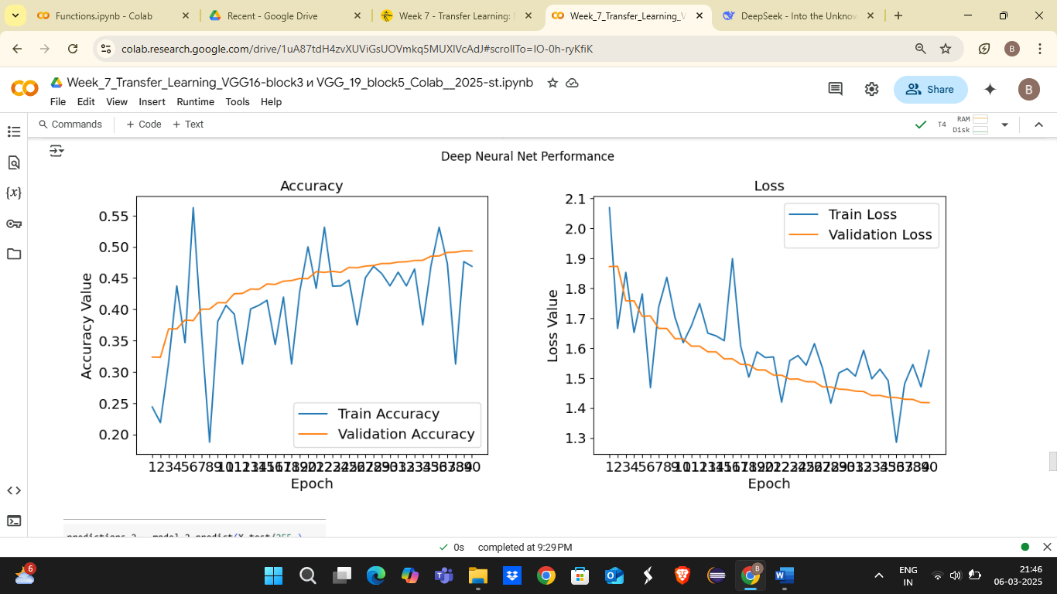

2. Based on this analysis, determine the optimal number of epochs for training your VGG16 model:

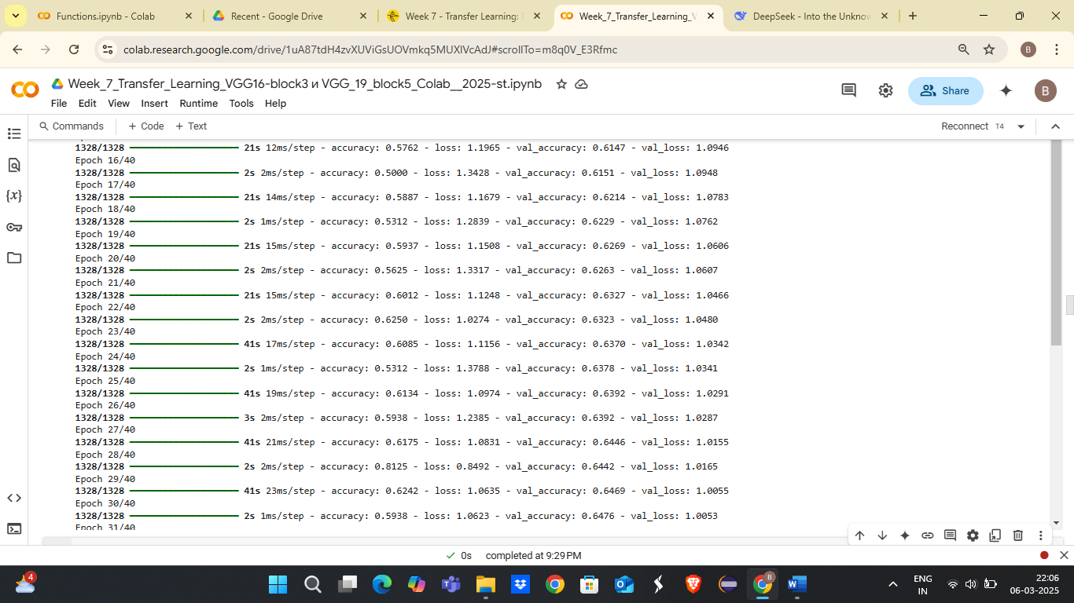

3. Add the final Performance Table:

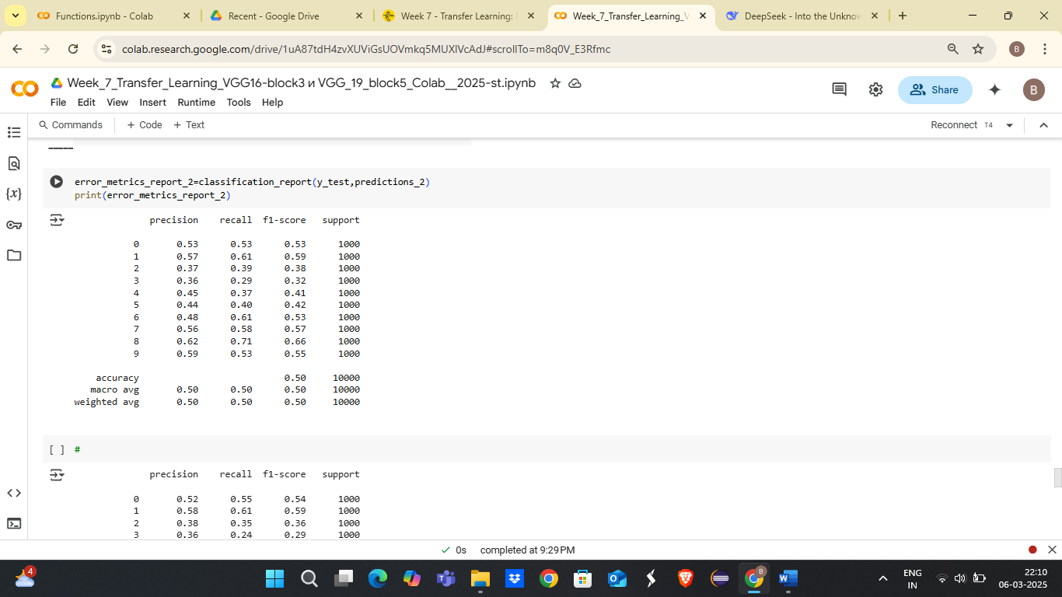

4. Plot the performance comparing histogram of VGG16 and VGG19:

